Muhammad Ali

***Address: # Street #2 ,Plot # 644, Sector #I,Manzoor Colony Karachi.***

***Contact # 0310-2063296***

**OBJECTIVE:**

**To secure a challenging career with dynamic ,Servicing Progressive organization in order to utilize my abilities ,knowledge and personal acumen with integrity contribute in the development**

**PERSONAL INFORMATION:**

* Father’s name : **Muhammad Aslam**
* Date of Birth **: 08-11-1998**
* NIC # **: 42301-3460098-9**
* Religion : **Islam.**
* Marital Status : **Un-Married.**
* Nationality : **Pakistan.**
* E-mail : **aliaslamshaikh20@gmail.com**

**QUALIFICATION:**

* **Matriculation(Science) (Sindh Board Karachi).**
* **Intermediate(Pre -Engg). (Aisha Bawani Govt**

**College Karachi).**

* **Undergraduate(BS-CS). (PAF-KIET Karachi).**

**SKILLS:**

* **Flutter Mobile App Developnment**
  + - Material design
    - Flutter primitives (Flutter widgets and dart code)
    - Responsive design
    - Network requests (REST APIs)
    - Firebase integration
    - Unit testing
    - Architectural patterns (bloc, redux, scoped model)
    - CI/CD
    - Publishing (Playstore/ AppStore)
* **C#.Net**
* Creating Window Application and Reusing Existing Code with OOP and Data Structure.
* **Python And C Language**
* Varaible, loop ,arrays list ,function and its concepts.
* **SQL(Server)**
* Queries and developing various objects like table and views.
* **Web Designing**
* **HTML**
* Creating Web Pages And Web Applications.
* **CSS**
* Creating Styles for your webpages and design.
* **JAVASCRIPT**
* Basic Know How About Form Validation.

**Project Repo On GitHub:**

* FINAL COURSE PROJECT(Online Furniture Shopping App):
* <https://github.com/Alliiiii/FlutterFurniterShoppingApp>

IMAGES OF FINAL PROJECT

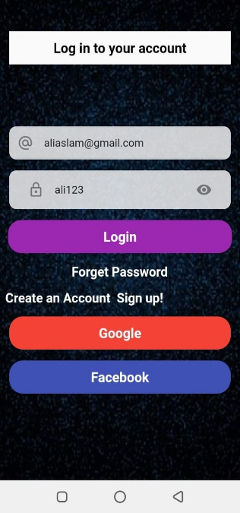 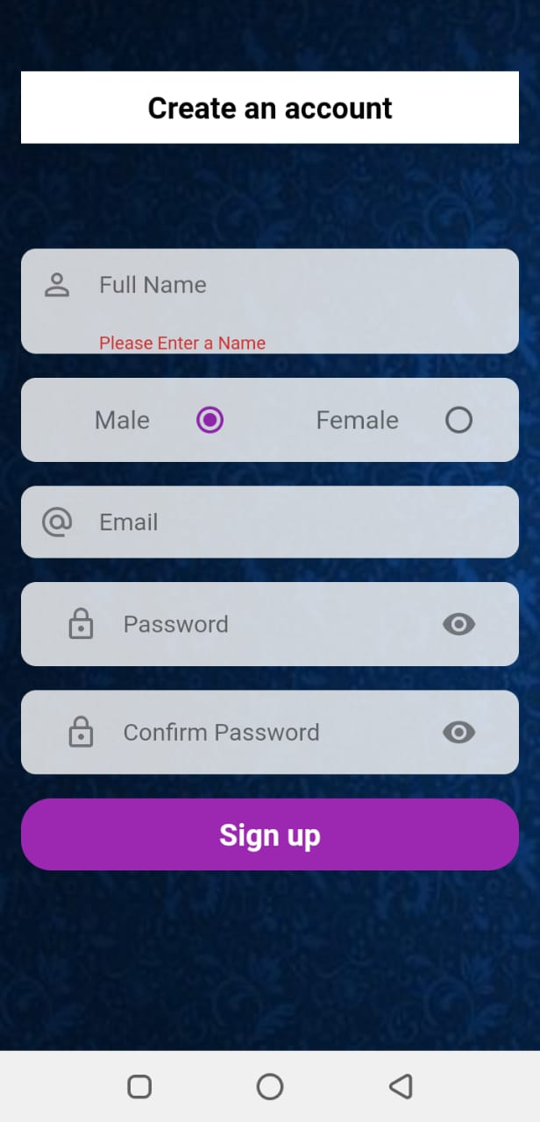 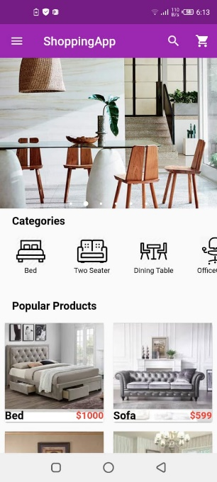 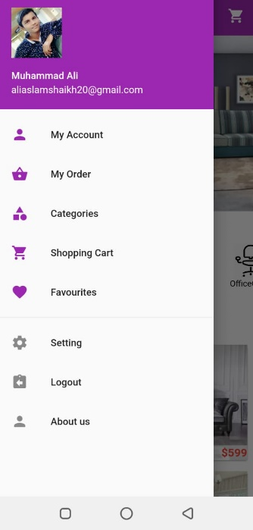

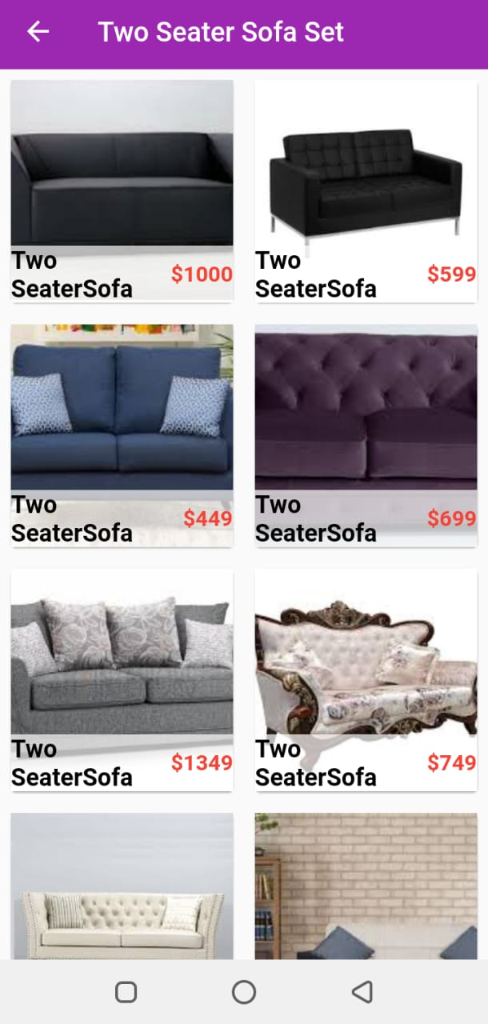 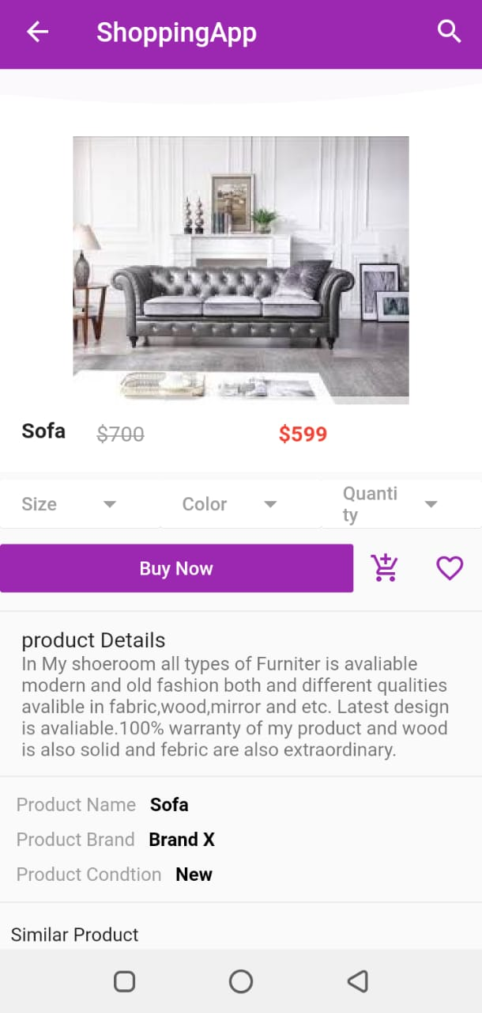 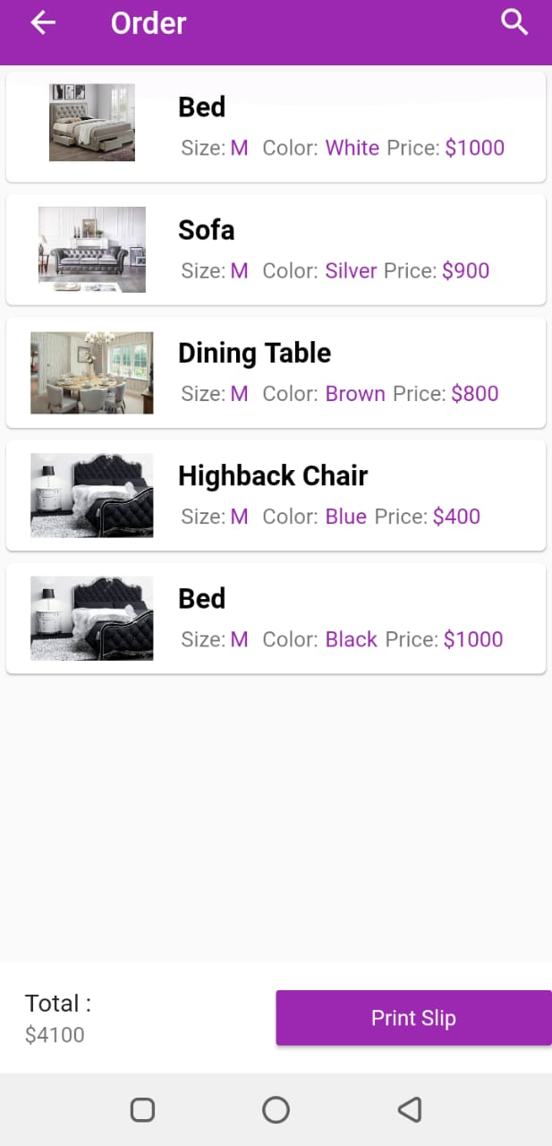

* **Flutter Training Task Link:**
* <https://github.com/Alliiiii/Gmail_layout_flutter>
* <https://github.com/Alliiiii/Tea_Cafe_project>
* <https://github.com/Alliiiii/flutertask5_chinesefoodlist>
* <https://github.com/Alliiiii/seesion5fluter_firebase_babynammes>
* <https://github.com/Alliiiii/session_4>
* <https://github.com/Alliiiii/session_3>
* **Artifical Intelligent University Course Project On Flutter**
* <https://github.com/Alliiiii/emotiondetection>
* <https://github.com/Alliiiii/machine_learning_flutter_app>
* <https://github.com/Alliiiii/speech_recognizer_flutter_app>

Recently I have Completed Training Of Flutter Mobile App Developnment From Sir Syed Univeristy(Apptron Technology) and the course which I covered is

* + - Basic Of Dart Programming Language.
    - Material design
    - Flutter primitives (Flutter widgets and dart code)
    - Responsive design
    - Network requests (REST APIs)
    - Firebase integration
    - Unit testing
    - Architectural patterns (bloc, redux, scoped model)
    - CI/CD
    - Publishing (Playstore/ AppStore).

And I have Completed My Five Semsters with Sucessfully form PAF-KIET main campus and I have also passed course courses of BS-CS .

* + - Programming Fundamentals.
    - Object Oriented Programming.
    - Data Structures.
    - Database Management Systems.
    - Operating System.
    - Artifical Intelligence,.
    - Object Oriented Analysis and Design.